6th grade Name:
Date:
INITIAL TEST

SECTION A: Listening Comprehension .........../ 10p.
1. You have 10 seconds to read each question. Listen and select the best picture. You have 10 seconds to choose the correct option. There are 10 questions in this section.

1. Where should people go when the bell rings?
A B C
2. Where is the woman?
A B C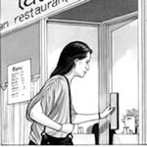
3. What time is the next train to London?
A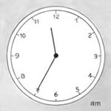 B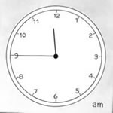 C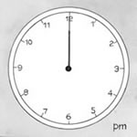
4. Which house is the man talking about?
A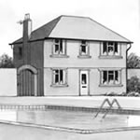 B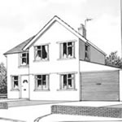 C
5. Where is Andy?
A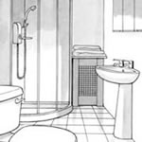 B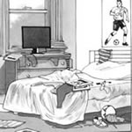 C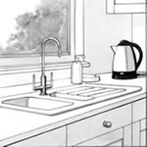
6. When is Chris repairing the heating?
A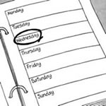 B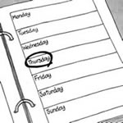 C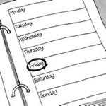

7. Where is the barbeque going to be?
A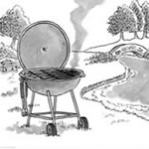 B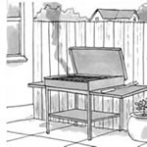 C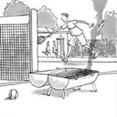
8. Where is Jane’s party?
A B C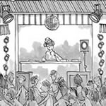
9. Which is the correct picture?
A B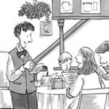 C
10. Who is the speaker?
A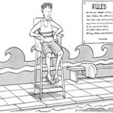 B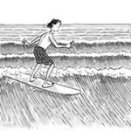 C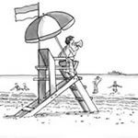

2. Jason is on holiday with some friends. He telephones his father. Listen to his telephone conversation and complete the postcard he sends to a friend.
........../ 10p.
Hi, Dave!
We arrived last night after a …………(1) journey by ……………….. (2) It’s …………(3) here but the …………….. (4) is a bit up and down. Yesterday it ……………. (5). But today is ……. (6) and …………….(7). In fact, the temperature today is ……………(8). There’s lots of ………. (9) high up in the mountains. They say the temperature is going to be …………..(10) tonight and it’s going to snow. I hope so!
See you, Jason

SECTION B: Reading Comprehension .........../ 15p.
I. Read the text and complete the chart below.
British teenagers speak out about their money
Spending power
James Moore, 13
I get £3.50 pocket money a week, from my Dad. I’m trying to get a job helping in the fruit market on Saturday mornings. I spend my money on clothes, CDs and magazines. I go out on Friday and Saturday nights to friends’ houses and to parties.

Rosie Davies, 14
I get £5 a week pocket money. I’ve also got some birthday money and some savings in a bank. I’m saving up to buy a CD player. I buy some of my own clothes, but I also spend quite a lot on chocolate and the cinema. At weekends I like going to visit friends and going to parties. I also like keeping fit, so I don’t drink or smoke.

Catherine Bethell, 16
I get £10 a week pocket money from my parents, and I earn another £15 a week from babysitting.I’m trying to save up for my summer holidays, but I still spend money on magazines, clothes and going out. I like going to discos, clubs and the cinema.

 | James | Rosie | Catherine
Spending money:  -pocket money  - job | ..... £3.50 a week.....  ........... -................ | ...........................  ............................ | ...........................  ............................
Spends money on: | .........clothes........  ..........CDs...........  .......magazines..... | ............................  ............................  ............................ | ............................  ............................  ............................
Social life: | ....visiting friends...  ...going to parties... | ............................  ............................ | .............................  .............................  .............................
II. Circle the correct response: .........../ 10p.
1. I’ve got free tickets to the Oasis concert.
- How often do you go? b) Of course not. c) You’re so lucky!
2. You’re so lazy!
a) That’s not true. b)No, I don’t. c) Of course not.
3. Do you go to the disco every night?
a) No, I’m not. b) No, it isn’t. c) Of course not.
4. How do you usually go to school?
a) By walk. b) I walk. c) I’m walking.
5. Can you dive?
a)No, I can’t. Can you? b) No, I can’t.Are you? c)No, I can’t. How are you?
6. How many of you are going?
a) Any of us. b) No, we can’t go. c) None of us.
7. Sam’s angry with us.
a) I don’t think. b) How do you know? c) Who do you know?
8. What do you think of this top?
a) It’s a bit tight. b) I don’t like them. c)I don’t think.
9. Come here!
a) What is it? b) That’s fine. c) Tell me.
10. Can we go to the disco?
a) OK, but don’t late. b) OK, but take home by eleven. c) OK, but be home by eleven.

SECTION C: Writing ......../ 35p.

I. Read the descriptions of some words about the free time that people have. What is the word for each one? ........./10p.

The first letter is already there. There is one space for each other letter in the word.
Example:
- If you like reading about music and fashion, you may buy this. m_ _ _ _ _ _ _
Answer: m a g a z i n e
1. People who like watching football often go to this place. s _ _ _ _ _ _
2. If you enjoy taking photographs, you will need this. c _ _ _ _ _
3. People who like swimming in the sea often go here. b _ _ _ _
4. You may play this instrument if you like music. g _ _ _ _ _
5. If you enjoy camping, you will need to take this with you. t _ _ _

II. Write a paragraph about how you get money and how you spend it. ......../ 25p.
Write:
- how much money you get every week or a month
- who or where you get it from
- what you spend it on
- how much you spend on your social life
- what you like doing
- if you save any of it.

Note
All subjects are compulsory.
Time: 50 minutes
Total score: 80 points

INITIAL TEST – Part 1
Answer Key
SECTION A: Listening Comprehension 20p.
I. (10x1p=10p)
1.B 2.A 3.B 4.C 5.C 6. B 7.A 8.B 9.A 10.C
II. (10x1p=10p)
1) long 2) bus 3) brilliant 4) weather 5) rained 6) warm
7) sunny 8) (about) ten degrees 9) snow 10) minus five

SECTION B: Reading Comprehension 25p.
I. (15x1p=15p)
 | James | Rosie | Catherine
Spending money:  -pocket money  - job | ..... £3.50 a week.....  ........... -................ | ........ £ 5 a week..  ............-............... | ...... £ 10 a week...  ........£15 a week...
Spends money on: | .........clothes........  ..........CDs...........  .......magazines..... | ....... clothes........  ......chocolate......  .......cinema......... | .....magazines......  ..... clothes...........  .....going out........
Social life: | ....visiting friends...  ...going to parties... | ....visiting friends...  ...going to parties... | ....going to discos,  clubs and cinema...

II. (10x1p=10p)
1.c 2.a 3.c 4.b 5.a 6.c 7.b 8.a 9.a 10.c

SECTION C: Writing 35p.
I (5x2=10p)
- stadium 2. camera 3. beach 4.guitar 5. tent
II. (25 points)
Completion of task 10 p.
Vocabulary 5 p.
Grammar 5 p.
Language accuracy 5 p.
___________
Total score: 80 points

Tapescript:
1. Listen to the man speaking. Where should people go when the bell rings?
M: Attention, please. There is going to be a fire drill in about one hour.When the bell rings, leave the office and go to the staff car park.

2. Listen to the woman speaking. Where is she?
F: I’ll be late to the restaurant, Peter. There was an accident outside the cinema and the traffic was terrible. I’m driving on the motorway now – see you in 20 minutes.

3. Listen to the people speaking. What time is the next train to London?
M: Excuse me. Does this train go to London?
F: No, this is the 11.35 service to Rochester. There’s a London train from platform 12 at 11.45.

4. Listen to the man speaking. Which house is he talking about?
M: You can’t miss our house, John. It’s in Cedar Avenue opposite a house with a pool in the garden.We haven’t got a garage so you’ll have to park in the street.

5. Listen to the people speaking. Where is Andy?
F: (mother) Andy, will you tidy your bedroom, please?
M: (teenager) I’ll do it later Mum. I’m doing the washing up.

6. Listen to the people speaking. When is Chris repairing the heating?
F: Hi, Chris. Our heating isn’t working. Can you come and repair it tomorrow?
M: Wednesday? That’s difficult. How about Thursday or Friday afternoon?
F: The sooner the better. Let’s say Thursday.

7. Listen to the people speaking. Where is the barbeque going to be?
F: Shall I meet you at your house?
M: OK, and then we can go to the barbeque together. It’s in the park by the river.
F: Yes, I know. Just after the tennis courts.

8. Listen to the girl speaking. Where is Jane’s party?
F: Hi, Mandy. Jane here. About my birthday party, Mum said ’no’ to the disco so we’re going bowling. Come to my house at six – you can come with me and my sister.
9. Listen to the woman speaking. Which is the correct picture?
F: Yes, that’s right – 11 High Street, Denton. And we’d like four pizzas, two bottles of coke and garlic bread for eight o’clock.
10. Listen to the man speaking.Who is the speaker?
M: Attention, please. Do not enter the water beyond the red flags. This area is for surfers only. No swimming beyond the red flags, please. (http://www.examenglish.com/PTE/pte_general_level1_listening_part1.htm)
2. Jason is on holiday with some friends. He telephones his father. Listen to his telephone conversation and complete the postcard he sends to a friend. ..../ 10p.
Tapescript:
Dad: Hello.
Jason: Hi, Dad, it’s me, Jason.
Dad: Hello, Jason. How’s everything?
Jason: Great! We arrived last night. It’s brilliant here.
Dad: What was the journey like?
Jason: OK. It was very long – well, it was by bus – but we stopped at lots of places on the way.
Dad: And what’s the weather like?
Jason: Well, it’s a bit up and down. Yesterday wasn’t very nice. It rained.
Dad: Rained? Oh, but surely it doesn’t rain at this time of year out there?
Jason: Sometimes it does, but today is lovely. It’s warm and sunny.
Dad: Oh, good. How are the others?
Jason: Well, Katie and Mike are sitting outside in the sun.
Dad: What’s the temperature?
Jason: It’s about ten degrees in the sun today, but it’s going to drop to minus five tonight.
Dad: What about the snow?
Jason: Oh, there’s lots of snow, especially here, high up. And they say it’s going to snow again tonight. The skiing is going to be really great tomorrow. Anyway, must go.
Dad: OK. Bye, Jason, thanks for calling.
(Source: Snapshot Starter, Teacher’s Book, 105)

